Vanlink Server 2.0
To use Server 2.0 please use “git checkout server_v2”.

User Route “/user”:

Get:
On making get request you will get the all user objects like bellow.
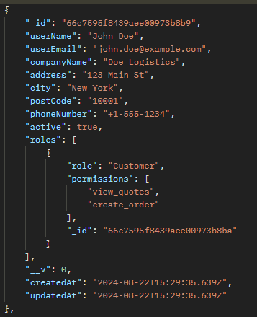

Post:
You need to send data in the following format: 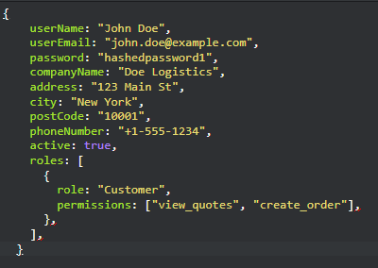

Update:
Update route will work just like before, just send the updated fields to the server it will update those fields only and leave the remaining fields as it is.

Delete:
Delete Route will only need id of object and it will delete that object.

Quotation Form “/quotation”
Quotation form have major update as it will accept the sub object to make things more clearer and maintainable. Moreover, we also going to save quotation price in this object.

Get:
On making get call you will get array of following objects:
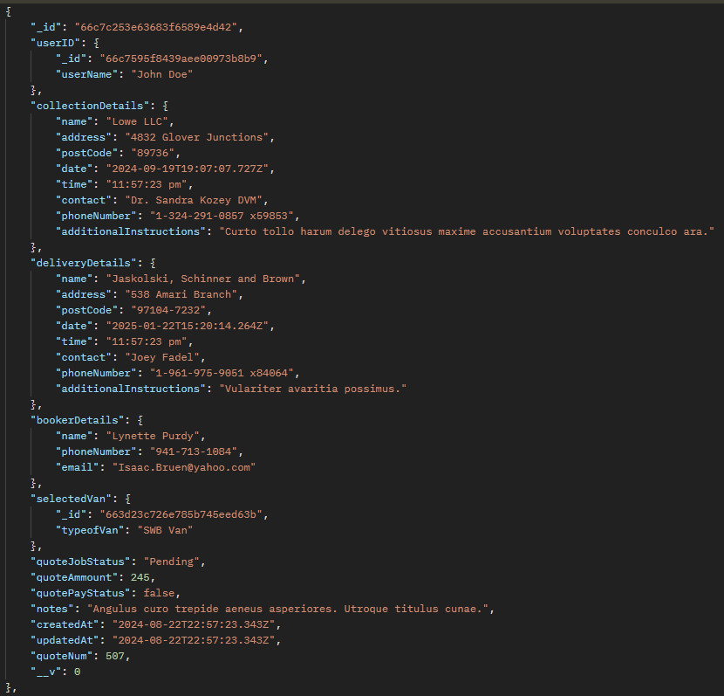
Now, you have got the Quotation Number as quoteNum, amount of this quote as well, however, to optimised the query, I use different way to get the username and selected Van. It is nested into their respective object.

Post:
You need to send data in the following object
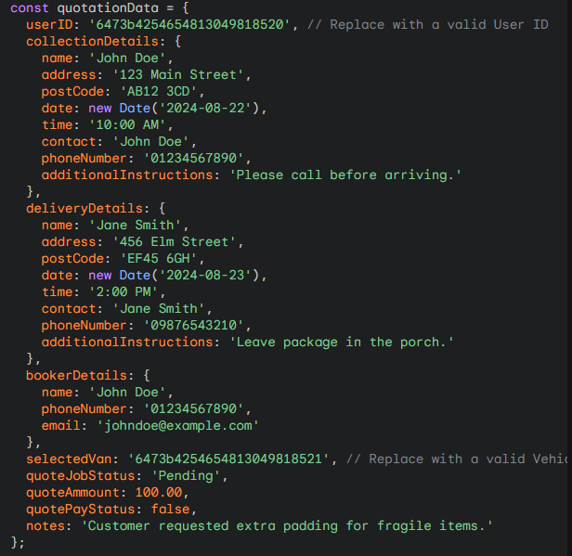
Ignore the date and time field as I was trying to create the dummy data. Actual data should be selected by user and validate it as date and time.

Update:

Delete:

